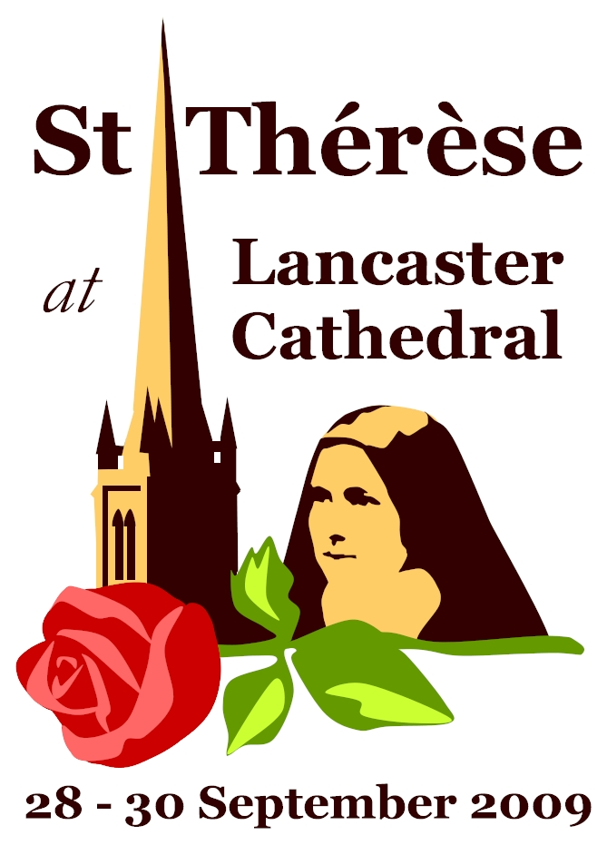
Diocesan Novena in preparation for the visit of St Thérèse
To run for nine weeks from 26 July 2009

Suggested format:
On Sundays: include the paragraph (or part of it) on parish newsletters, or use some of the ideas in preaching where appropriate; also use the intercession given for each week.

On weekdays, announce the week’s prayer intention each day; also use the prayer for the visit (text below) each day (perhaps at the end of Mass).

Prayer for the Visit to Lancaster
Lord Jesus,
We thank You for Your gift of Saint Thérèse to our world.
May her courageous confidence in Your loving providence
and her burning desire to make You known and loved
be a constant inspiration to us as we seek to follow
in her “Little Way” of total loving. Amen.

Saint Thérèse, pray for us

Week-by-Week texts for the Novena:

26 July 2009: 17th Sunday in Ordinary Time
Theme: The Sick

Recently the annual Diocesan pilgrimage to Lourdes took place. The shrine has always been a place of prayer for the sick, and St Thérèse’s mother, Blessed Zélie Martin, made a pilgrimage there when she was diagnosed with cancer. Thérèse herself was just 24 when she died. For the last 18 months of her short life she suffered great illness, and on 30th July 1897 (112 years ago this week) she received the anointing of the sick. Today’s readings remind us that God provides for His people in their need; this week we pray that He will provide the sick with healing and with a constant sense of His presence.

Intercession:
Let us pray for all who suffer with illness – that the example and prayers of St Thérèse will help them to unite their suffering with the Lord’s cross.

2 August 2009: 18th Sunday in Ordinary Time
Theme: Priests, vocations to the priesthood

On Tuesday we celebrate the feast of St John Vianney, the patron saint of priests throughout the world. It is 150 years since he died, and Pope Benedict has asked us to mark the anniversary by keeping a year of prayer for priests. During her life in Carmel St Thérèse dedicated herself to praying for two young missionary priests. In this way she supported their efforts to bring Christ to others. As we hear Jesus in the Gospel describe Himself as ‘the Bread of Life’, we thank God for the priesthood, by which the Eucharist is given to us.

Intercession:
Let us pray for priests and for vocations to the priesthood – that by the intercession of St Thérèse and St John Vianney the Church may always have holy and dedicated priests to serve God’s people.

9 August 2009: 19th Sunday in Ordinary Time
Theme: Youth

With exam results due soon, this week we pray for young people. This week in 1921 Pope Benedict XV issued a decree on the ‘heroic virtues’ of St Thérèse and so made her a model for young people to follow. Thérèse was a headstrong child and from an early age was certain of the path which God had chosen for her. When she applied to enter Carmel at age 15, she was denied entry because she was too young, but Thérèse was not prepared to let her youthfulness stand in her way. After a determined struggle she obtained permission from her family, from the Prioress and from the local Bishop. Just 24 years old when she died, Thérèse became a natural patron for the youth. As we prepare for her visit we pray for young people, that – in the words of St Paul – they may imitate God and follow Christ.

Intercession:
Let us pray for young people, especially those who are awaiting exam results – that by the prayers of St Thérèse they may find and follow the path which God has chosen for them.

16 August 2009: The Assumption of Our Lady

Theme: The Pope and his intentions

On a pilgrimage to Rome in 1887 Thérèse had an opportunity to meet Pope Leo XIII. She had been told in advance that she should remain silent. Unable to stop herself, however, she made her request: she wanted to become a Carmelite at 15 and asked the Pope for his permission. “If it is God’s will, you will enter”, he replied. From the desire of this individual to the pressing concerns of the whole Church, the Pope is charged with the responsibility of leading the world to Christ. Pope Benedict’s intentions for this time include prayer for refugees and displaced peoples, and for Christians suffering persecution or discrimination; we pray for him and for his intentions, as Thérèse did during her time in Carmel.

Intercession:
Let us pray for Pope Benedict – that by the intercession of St Thérèse he may be sustained in his task of leading the Church.

23 August 2009: 21st Sunday in Ordinary Time
Theme: Family Life

Thérèse was fortunate to be born into a loving family, but her happiness was short-lived. Her mother Zélie died on 29 August 1877 (132 years ago this week), when Thérèse was just four years old. The family home was a faith-filled environment, from which Thérèse and all four of her surviving sisters entered religious life. Her father, with whom she was very close, suffered with dementia at the end of his life, and this caused Thérèse and her sisters great pain. Last October Thérèse’s father and mother were beatified: now Blessed Louis and Zélie Martin are venerated as models of holiness in married life. As today we hear St Paul remind us that love is at the heart of both family life and the Church, let us pray that all families may grow in holiness and in love.

Intercession:
Let us pray for families – that by the prayers of St Thérèse and of her blessed parents, all homes may be places of holiness and love.

30 August 2009: 22nd Sunday in Ordinary Time
Theme: Conversion of Sinners

In early September 1887 Thérèse read an account of the execution of a murderer by the name of Pranzini. She already knew of this man and had spent much time praying that he might repent of his crime before his death. He had shown no sign of remorse until – moments before his execution - he asked for a crucifix and kissed it. Thérèse took this as a sign that her prayers had been answered, and rejoiced that a soul had been saved. In today’s first reading we hear of the value of God’s Law, and in the Gospel reading Jesus criticises those whose hearts are far from God, even when they pay Him lip service. This week let us pray for the conversion of those who have turned from God, and ask that each of us may sincerely try to follow God’s will.

Intercession:
Let us pray for conversion - that all of us, especially those who are far from God, may return to Him with the help of the prayers of St Thérèse.

6 September 2009: 23rd Sunday in Ordinary Time
Theme: Religious

On 8th September 1890 Thérèse – still just 17 years of age – made her final profession, committing the rest of her life to Carmel. For the remaining nine years of her time on earth she lived a life of prayer and service. Although she never left the confines of the monastery she served the world by her prayers. Throughout the world today there are countless religious women and men who devote their lives to prayer and service, living lives of poverty, chastity and obedience. In the words of St James, they are “poor according to the world but rich in faith.”

Intercession:
Let us pray for those who live the religious life – that by the intercession of St Thérèse they may be faithful to their calling.

13 September 2009: 24th Sunday in Ordinary Time
Theme: those who doubt/struggle with their faith

For the final 18 months of her life, Thérèse endured great suffering as the result of illness. Alongside this there was a form of spiritual suffering, as she felt that heaven “was closed” to her. She never lost her faith, but found it impossible to feel God’s presence. This experience of darkness for Thérèse reminds us how great a gift it is to have a sense of God’s presence in our lives; it is an invitation to pray for those who have no faith or who struggle to believe. Jesus’ question in the Gospel is also meant for each of us: “Who do you say I am?” This week we pray for a deeper, stronger faith in Christ.

Intercession:
Let us pray for those who struggle to believe in Christ – that by the prayers of St Thérèse they may find certainty in the truth which God has revealed to us.

20 September 2009: 25th Sunday in Ordinary Time
Theme: The lapsed and the missions

In Carmel for the last nine years of her life, Thérèse never set foot outside of the monastery. Yet she greatly desired to be a missionary, and would like to have gone to Vietnam to promote the spread of the Gospel. Missionaries and the work of evangelisation became a special focus of her prayer, as she longed to draw people close to Christ. On this Home Mission Sunday, as we begin the final week before her relics visit our Diocese, we pray that Thérèse may help those who have fallen away from practising their faith. She once said that she wanted to be a missionary “until the end of time.” May her wish be fulfilled in our Diocese.

Intercession:
Let us pray for all who no longer practise their faith, and for the spread of the Gospel throughout the world – that by the intercession of St Thérèse people everywhere may hear and respond to the Gospel.

27 September 2009: 25th Sunday in Ordinary Time
Although the novena now ends, please encourage parishioners to pray that the visit may be a success. You may wish to use the following intercession:

Let us pray that the visit of the relics of St Thérèse may be a source of grace for all the people of our Diocese.

All of the novena texts are available online, so you can download them and cut-paste into your newsletter. Go to www.lancastercathedral.org.uk or search online ‘St Therese in Lancaster’ to find our pages dedicated to the visit.

Some suggestions for following up the visit
- This visit provides an opportunity to revive the great Catholic tradition of asking the intercession of the saints. Between the visit and the feast of All Saints there is a window to encourage devotion to the saints, particularly parish patrons.
- Local prayer groups might be established. These could use some of St Thérèse’s own words for prayer, or be established to pray for intentions close to Thérèse’s heart.
- Parishioners may be encouraged to support organisations inspired by St Thérèse, such as the Little Way Association or the Society of the Little Flower.
- The feast of St Thérèse each year might be marked with devotions, particularly in those parishes which have a statue or image of her.

